Instruction Manual- Rebounder 
www.traditionalgardengames.co.uk
Parts List Assembly Steps
Step 1: Hitch Part 5 & Part 8 onto tubes by elastic ropes , the position is followed picture shows (Picture 1);
Step 2: Joint tubes and ensure the pop ball in tube can jump out of the hole.
Picture 1 Picture 2
Step 3: Hook Part 6 onto Part 5, please make sure that the 4 red labels are in each corners of frame.
Step 4: Round Part 7 through Part 6 as the target area.
Step 5: Please ensure Part 8 is fixed into the earth and the frame is stable on the ground.
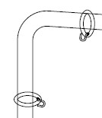⑤

